**LEARNING STYLES CLASSIFICATIONS**

**Supervised Machine Learning**

* The data provided to the model **guides** it in predicting outcome.
* It uses **mathematical functions’** **mappings**.
* Used in **detection**, **classification**, **filtering** & **assessment**.

Working of supervised learning:-

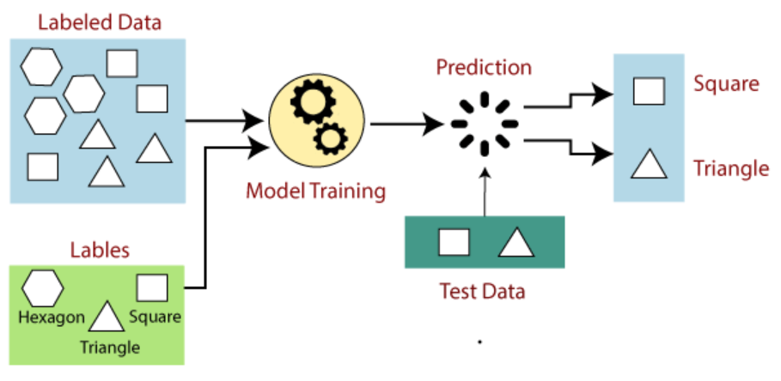

* For the example here, the model is trained on various **types of shapes**.
* It is fed with data about **various shapes** & the **number of sides** they can have.
* And when they are given **test data**, they identify each shape as per their number of sides.

Steps involved in supervised learning:-

* **Step 1:** **Select** the **type of data** to be used.
* **Step 2:** **Gather** the labelled **training data**.
* **Step 3:** **Split** the dataset into **training** & **test** **dataset**.
* **Step 4:** **Decide** what **inputs** the model should take from users.
* **Step 5:** **Choose** a suitable **algorithm** for the model.
* **Step 6:** **Apply** **algorithm** on the **training dataset**.
* **Step 7:** **Test** the **accuracy** of the model.

**Regression**

* Used when there is a **relation** between **input** & **output** variable.
* Used for predicting **continuous variables**.
* **Continuous variables:** Variables which are **measured**, **not counted** & **range to infinity**.

Popular regression algorithms:-

* Linear regression
* Regression trees
* Non-linear regression
* Bayesian linear regression
* Polynomial regression

**Classification**

* Used for giving **categorical output**.

Popular classification algorithms:-

* Random forest
* Decision trees
* Logistic regression
* Support vector machines

**Pros & Cons of Supervised Learning**

Advantages:-

* Predicts on the basis of **experience**, thus more prone to give **correct answer**.
* **We** **know** how the class of objects will **behave**.
* **Class of objects:** Variables/elements used as **input** in algorithms.
* Helps in solving **real world problems** like ***fraud detection***, ***spam filtering*** etc.

Disadvantages:-

* Can’t handle **complex tasks**.
* Can’t predict **correct output if** test data is different from training data.
* Training consumes **heavy computation** time.
* We need **too much details** about the input.

**Unsupervised Learning**

* Uses **unlabelled** data.
* The model finds the hidden pattern from data **itself**.
* Similar to how humans **intuitively** find pattern in **aptitude questions**.
* Closer to working of an AI.

Working of unsupervised learning:-

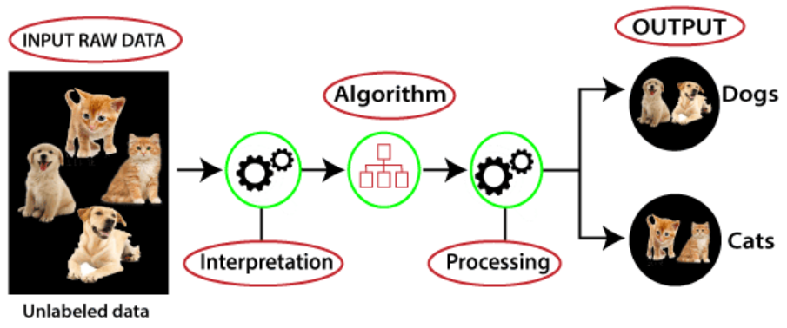

* The model chooses the suitable algorithm **itself**.
* After applying the algorithm, the model divides the objects into groups.

**Clustering**

* Also known as ***cluster analysis***.
* Groups similar data with **commonalities** into same group.
* Data with less or no similarity are kept in different group.
* These groups are known as ***clusters***.

**Association**

* Finds **relationship between variables** in a given dataset.
* Determines items which **appear together**.
* Association rule helps making **stronger marketing strategy**; using ***market basket analysis***.

**Example:-**

**A person X buys *bread*.**

**Then he might also buy *jam* or *butter* with it.**

**Popular Unsupervised Learning Algorithms**

* K-means clustering
* KNN (k-nearest neighbours)
* Hierarchal clustering
* Anomaly detection
* Neural networks
* Principle component analysis
* Independent component analysis
* Apriori algorithm
* Singular value decomposition

**Pros & Cons of Unsupervised Learning**

Advantages:-

* Can be used for more **complex tasks**.
* Its **easier** to get/find unlabelled data.

Disadvantages:-

* Might be **less accurate**.

**Supervised v/s Unsupervised Learning**

|  |  |
| --- | --- |
| **Supervised Learning** | **Unsupervised Learning** |
| **Takes feedback.** | **Doesn’t take any feedback.** |
| **Predicts output.** | **Finds hidden patterns.** |
| **Is given input & output (equation) both.** | **Is given input only.** |
| **Comparatively more accurate.** | **Comparatively less accurate.** |